ACTIVITY 1.3 Life expectancy

1. Refer to the graph in Figure 1.4 and identify the main trend shown by the data.

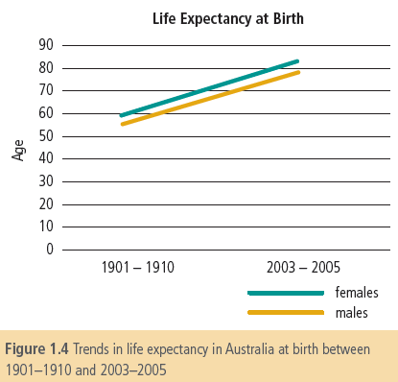

2. Describe the changes in life expectancy for males and for females between 1901 and 2005.

3. Identify some factors in the environment that may be involved in causing the changes to life expectancy in Australia over time.

4. Describe the difference between male and female life expectancy from the data shown in the graph.

ACTIVITY 1.4 Burden of disease

1. Define YLL and YLD (refer to Figure 1.5 if you need help).

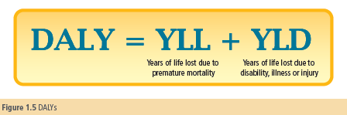

2. Why has burden of disease been developed as a measure of health status? What is it measuring?

3. Which diseases were the two leading causes of burden of disease in Australia in 2003?

4. For these two diseases, were there more DALYs due to death or more DALYs due to disability?

5. Identify the number of DALYs for each of the fatal component and the non-fatal component for injuries.
