The role of Australia’s governments in promoting healthy eating through the Information produced by Nutrition Surveys

Key knowledge you need to have includes:
“The role of Australia’s governments in promoting healthy eating through:
- the information provided by nutrition surveys and how it is used”

Key skills you need to develop include the ability to:
1. Analyse the different approaches to health and health promotion;
2. Explain and draw informed conclusions about the role of government and non-government agencies in promoting healthy eating.
TASK:
The 2007 Australian National Children’s Nutrition and Physical Activity Survey (Children’s Survey) was commissioned by the Department of Health and Ageing, the Department of Agriculture, Fisheries and Forestry, and the Australian Food and Grocery Council.

The objective of the Children’s Survey was to assess the food and nutrient intake, physical activity participation and to measure weight, height and waist circumference in a sample of children aged 2–16 years randomly selected from across Australia.

- Research ‘The 2007 Australian National Children’s Nutrition and Physical Activity Survey – Major Findings’ (AGPS, Canberra):
www.health.gov.au/internet/main/publishing.nsf/content/phd-nutrition-childrens-survey
a. Outline 5 ways that information from nutrition surveys such as this is used.
b. Produce a selective summary of the findings from the survey by downloading & completing Tables 1 & 2.
An example of each is done as a guide to what is required. Graphics are recommended for memory support!

- Select two of you findings from “The 2007 Australian National Children’s Nutrition and Physical Activity Survey”.
- One from the Food & Nutrition findings
- One from the Physical Activity & Body Size (Weight, Height & Waist Circumference) findings
Identify & briefly explain a strategy for each of these findings that government or non-government organisations have developed to make improvements to health status based on these results.
Present your findings in Table 3.
Consider the following links for programs/strategies:
http://www.healthyactive.gov.au/
http://www.nutritionaustralia.org/vic/community-programs
http://www.nutritionaustralia.org/vic/schools-programs http://www.heartfoundation.org.au/Pages/default.aspx
http://www.vichealth.vic.gov.au/en/Programs-and-Projects/Healthy-Eating.aspx http://www.vichealth.vic.gov.au/Programs-and-Projects/Physical-Activity/Physical-activity-programs.aspx

TABLE 1
Summary of the Survey Findings – Food & Nutrition
Food & Nutrition | Key points from the survey | Implication for Health into adulthood
1.  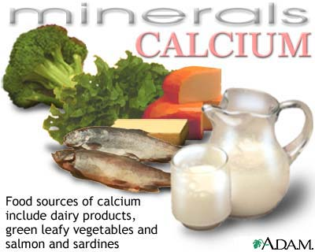 | The intake of milk products for 14–16 year old girls was approx. 30% lower than 2–3 year old girls.  The older girls (14–16 years) appeared to be most at risk of not meeting their dietary requirements for calcium (82–89% did not meet the EAR).  (EAR = The level of the nutrient required to meet the of half the healthy individuals of a specific sex & age)  Similarly, older boys (14–16 years) were least likely to reach their EAR for calcium (44% did  not meet the EAR ) | A food intake low in calcium & phosphorus  Prevents bone from developing normally & results in reduced bone mass. If peak bone mass is not achieved in adolescence / early adulthood there is an increased risk of osteoporosis later in life.  Especially important for girls as after menopause calcium is lost from bones more quickly due to lowered oestrogen levels
2.

3.

4.

TABLE 2
Summary of the Survey Findings – Physical Activity & Body Size
Physical Activity | Key points from the survey | Implication for Health into adulthood
1.Levels of physical activity  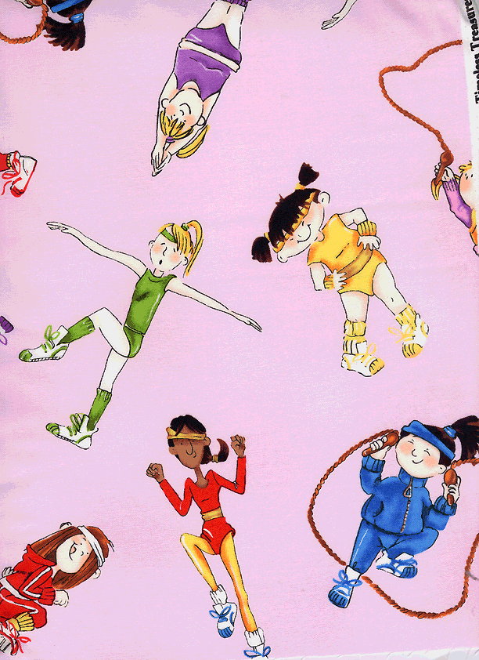 | Underweight and obese children tended to have a lower physical activity level (PAL ) than children of normal weight.  Adolescent girls achieved lower levels of physical activity than boys and fewer girls aged 14–16 years complied with the physical activity guidelines than boys. | Excess body weight in childhood:  Overweight young people are more likely to be overweight or obese in adulthood  Inadequate physical activity can lead to putting on excess weight when food intake is greater than energy expended
2.

3.

TABLE 3
Program | Link to Survey | Explanation of program | Specific Action it takes | Implication for Improved Health
- Swap it, Don’t stop it | Levels of physical activity | Federal Government program aims to show people how they can improve their health by making small changes to their daily routine  Eg using the stairs instead of a lift  Targets  Parents 25-50 as they influence their children’s activity levels | Advertising campaign  Eric swaps less healthy activities  for healthier ones (TV, radio,  magazines, billboards, online)  Website  Provides reasons for swapping,  ways to swap, resources to download eg  12 week program  Template to plan activities, meals  iphone app  Tracks progress/ shopping lists | Addresses risk of:  Obesity:  Physical inactivity means less energy is expended which can lead to increased body weight.  Obesity is a risk factor for CVD, Type 2 Diabetes & some cancers in adulthood  Mental Health issues:  Depression, anxiety & stress – exercise can help relieve stress & produces endorphins hormones that promote a sense of wellbeing  Osteoporosis:  Weight bearing exercise helps strengthen the musculo-skeletal system & helps reduce risk of osteoporosis
2
3.

