HEALTH AND HUMAN DEVELOPMENT Units 3 & 4
Early Commencement Program 2013

Rationale

Through the study of VCE Health and Human Development Units 3 and 4, students investigate health and human development in Australian and global communities.

Unit 3: focuses on Australians’ health and health system. Health is seen as a dynamic condition that is influenced by complex inter-relationships between various biological, behavioural and social factors. These interrelationships are reflected in a social view of health that sees health as being created in the settings where people live and work. This social view of health recognises the need for personal skills development, the importance
of empowering communities to take action to promote health, the creation of social and physical environments that are supportive of health and development, an awareness of the impacts on health of public policies and the need for health services to be oriented towards health promotion and the prevention of ill health.

Unit 4: takes a global perspective on health and human development
and uses definitions of human development that are consistent with approaches taken by both the World Health Organization (WHO)
and the United Nations (UN).
The study of Health and Human Development is based on the premise that health and human development needs to be promoted at all levels of society in order to maximise global development potential. The study also promotes the understanding that nutrition plays a major role in influencing health status.

Assessment

Unit 3: Australia’s Health | Unit 4: Global Health and Human Development | Allocated marks end of year
Outcome 1 [30% + 30%] | Outcome 1 [30% + 30%] | SACs Unit 3 25%
 |  | SACs Unit 4 25%
Outcome 2 [40%] | Outcome 2 [40%] | Examination 50%
 |  | Total 100%

Suggested websites: | Holiday Homework:
- Australian Institute of Health and Welfare : www.aihw.gov.au Visit this website and subscribe to receive the latest media release notices  - Better Health Channel: www.betterhealth.vic.gov.au  - VCAA for HHD Study Design and past Exams  http://www.vcaa.vic.edu.au/vce/studies/healthnhuman/healthumindex.html  - AusAID’s Focus magazine: http://www.ausaid.gov.au/focusonline/ | Students must complete and submit the following work on the first day of Term One:  - ALL sections of the ECP Booklet  - ALL Chapter questions – 1  - Cue cards - key Health Indicators

For students who have studied Units 1 and 2

Similarities
- The key concepts of health, for example the dimensions of health, burden of disease, health status, are used in exactly the same way.
- The measurements of health status, e.g. life expectancy, health adjusted life expectancy (HALE), disability adjusted life years (DALY), prevalence, incidence stay the same and are widely used throughout Units 3 and 4.

Differences
- The determinants of health: in Units 1 and 2 there were the biological, behavioural, physical environment and social environment determinants. In Units 3 and 4 we have the biological, behavioural and social
- The study of nutrients: in Units 1 and 2 you studied nutrients required for growth and development, including hard tissue, soft tissue development as well as energy and blood production. In Units 3 and 4 we have nutrients for health only
- ‘Human development’ takes on a different interpretation: in Units 1 and 2 ‘development’ refers to ‘individual human development’, i.e. of a person and through the various stages of their lifespan. In Unit 4 human development is at a societal and global level and is never about individual development.

New Course – beware of old material
Beware of using textbooks, online podcards, past students’ notes, etc. that are pre-2010. Use the new Jacaranda textbook and StudyOn booklet as well as books that are recommended by your teacher only. If in doubt, ask your teacher if a book or resource is relevant to the new course before using it.

How to Succeed In This Study:

- Start out organised and stay organised – have a separate folder for each of the six SACs and use tabs.
- Complete separate revision notes for each SAC. .
- Constantly compare your notes with the Key Knowledge and Key Skills Checklist (page 3) to make sure you have covered every dot point – they are all examinable.
- Keep up to date with your work.
- Separate and thorough Exam preparation is essential (the Exam is worth 50% of your final mark!!).

Holiday Homework:
** This must all be completed and handed in on the first lesson
- Complete any of the work not completed in class. This is all part of your compulsory mark offs for Unit 3 Outcome 1.

- Complete the glossary cards – please put onto cards (make your own or purchase some from Officeworks or Kmart). This is also a compulsory part of the first SAC which must be completed to be able to pass it. They also become a very useful study tool later on in preparing for exams and SAC’s.
Glossary Words for Assessment Task One:
- Health
- Health Status
- Life Expectancy
- Mortality
- Morbidity
- Health-adjusted life expectancy (HALE)
- Infant Mortality rate
- Years of Life Lost (YLL)
- Prevalence
- Incidence
- Disability adjusted life years (DALY)
- Burden of disease
- Socio-economic status
- Indigenous populations
- Determinants of health
- Social determinants of health
3.Read chapter one and complete review questions
Key Knowledge and Key Skills Checklist - Unit 3

KEY KNOWLEDGE - Unit 3 Outcome 1 |  | KEY SKILLS - Unit 3 Outcome 1
SAC One |  | SAC One | 
• definitions of physical, social and mental dimensions of health and health status; |  | • define key health terms;
• different measures of health status of Australians, including the meaning of burden of disease, health adjusted life expectancy and DALYs, life expectancy, under-five mortality rate, mortality, morbidity, incidence, prevalence;
• health status of Australians compared with other developed countries, including Sweden, United States of America, United Kingdom and Japan; |  | • analyse data about the health status of Australia’s population and that of other developed countries;
• variations in the health status of population groups in Australia, including males and females, higher and lower socio-economic status groups, rural and remote populations and indigenous populations; |  | • interpret and analyse data to compare the health status of selected population groups in Australia;
• biological, behavioural and social determinants of health in explaining variations in health status; |  | • use the determinants of health to explain differences in the health status of Australians and between population groups;
SAC Two |  | SAC Two
• the NHPAs including: – key features, determinants that act as risk factors and reasons for selection of each NHPA  – direct, indirect and intangible costs to individuals and communities of NHPAs  – one health promotion program relevant to each NHPA; |  | • explain and then justify one health promotion program that addresses each NHPA;
• glycaemic index and function and food sources of major nutrients as a determinant of health, including protein, carbohydrate (including fibre), fats (mono, poly, saturated and trans), water, calcium, phosphorus, iron, fluoride, iodine, sodium, vitamin A, vitamin D, vitamin C, folate and B12; |  | • explain the functions and identify food sources of the major nutrients required for health;
• the role of nutrition in addressing the following conditions recognised in the NHPAs: cardiovascular health, diabetes mellitus, colorectal cancer, obesity and osteoporosis. |  | • explain the role of nutrition in addressing specific conditions within the NHPAs.
KEY KNOWLEDGE - Unit 3 Outcome 2 |  | KEY SKILLS - Unit 3 Outcome 2
SAC Three |  | SAC Three
• models of health and health promotion including:  – biomedical model of health  – social model of health  – the Ottawa Charter for Health Promotion; |  | • analyse the different approaches to health and health promotion;
• the role of VicHealth in promoting health including its mission, priorities and how it reflects the social model of health; |  | • describe the role, values and priorities of VicHealth  • identify the principles of the social model of health evident in a project used by VicHealth;
• potential health outcomes of a VicHealth funded project; |  | • describe potential health outcomes of a VicHealth funded project for promoting health;
• Australia’s health system including – local, state and federal governments’ responsibility for health including funding  – the values that underpin the Australian health system  – Medicare, Pharmaceutical Benefits Scheme (PBS) and private health insurance; |  | • identify and explain key components of Australia’s health system;
• the role of Australia’s governments in promoting healthy eating through:  – the information provided by nutrition surveys and how it is used  – the purpose of Nutrient Reference Values to guide dietary intake  – the Australian Guide to Healthy Eating and Dietary Guidelines  – legislation developed by Food Standards Australia and New Zealand governing the safety and quality of food; |  | • explain and draw informed conclusions about the role of government and non-government agencies in promoting healthy eating.
• the role of Australia’s non-government agencies, including Nutrition Australia and the Heart Foundation, in providing dietary advice to promote healthy eating.

What is health?
Defining Health

World Health Organisation (WHO) definition,1946:  ‘a state of complete physical, mental, and social well-being and not merely the absence of disease or infirmity..’ | What are the limitations of this definition?

Definitions of the three dimensions of health:

Physical dimensions of health: Relates to the efficient functioning of the body and its systems, and includes the physical capacity to perform tasks and physical fitness.

Social dimensions of health: Being able to interact with others and participate in the community in both an independent and cooperative way.

Mental dimensions of health: ‘State of well-being in which the individual realises his or her own abilities, can cope with the normal stresses of life, can work productively and fruitfully, and is able to make a contribution to his or her community.’ (WHO, 2009)

1a. Match the following examples of health characteristics with the correct dimension of health (by placing a tick in the correct column).

Example of health characteristic | Physical | Social | Mental
Being free from disease
Coping with stress
Grieving the death of a close friend
Communicating positively with others
Having an ideal body weight
Having a good level of fitness
Accepting responsibility for your actions
Getting along with work colleagues
Managing your feelings
Having positive thought patterns
Getting enough sleep
Having goals in life
Having positive self esteem
Having a strong immune system
Having a supportive family or network of friends
Behaving in a socially acceptable manner
Getting involved in a local youth club
Ability to make effective decisions
Being fully vaccinated

1b. Assess your current health status using the three dimensions of health and place a mark on the continuum below.
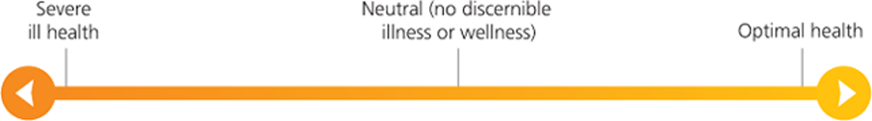

Justify your assessment using the three dimensions of health:
_____________________________________________________________________________________
_____________________________________________________________________________________
Measurement of Health Status

The terms below are all HEALTH INDICATORS, that is, they are standard statistics that are used to measure and compare health status.

Term | Definition
Burden of disease | A measure of the impact of diseases and injuries, specifically it measures the gap between current health status and an ideal situation where everyone lives to an old age free of disease and disability. Burden of disease is measured in a unit called the DALY.
YLD (Years Lost due to Disability) | The number of healthy years lost due to disease, illness or injury
YLL (Years of Life Lost) | Years of life lost due to premature death
Disability adjusted life year (DALY) | A measure of burden of disease, one DALY equals one year of healthy life lost due to premature death and time lived with illness, disease or injury.
Life expectancy | An indication of how long a person can expect live, it is the number of years of life remaining to a person at a particular age if death rates do not change.
Health Adjusted Life Expectancy (HALE) | It is the number of years in full health that a person can expect to live, based on current rates of ill health and mortality.
Morbidity | ‘Refers to ill health in an individual and the levels of ill health in a population or group.’
Mortality rate | The number of deaths over a period of time.
Prevalence | The number or proportion of cases of a particular disease or condition present in a population at a given time.
Incidence | The rate at which a particular disease/condition occurs over a period of time.
Health status | An individual’s or a population’s overall health, taking into account various aspects such as life expectancy, amount of disability and levels of disease risk factors.
Under-five mortality rate | The number of deaths of children under five years of age per 1000 live births.

1c. Your task: Create a set of cue cards using the key terms and definitions above. Use these for a game of concentration and later as an excellent resource for revision. Bring to first lesson.
2. Make a list of the sort of information you would want to access if you were asked to make a statement about the health of Australians.

__________________________________________________________________________________________________________________________________________________________________________________________________________________________________________

3. Victorian burden of disease study
Use the internet to access the Victorian Burden of Disease Study: Morbidity and Mortality 2001 at http://docs.health.vic.gov.au/docs/doc/6AEAFAB1BAE696B9CA257886000158A0/$FILE/bod_2001.pdf
- Go to page 59 of this document

Figure 3: The mortality burden in YLLs by sex and broad disease grouping, Victoria, 2001

a. Explain the term Years of Life Lost.
______________________________________________________________________________
b. List the four leading causes of premature mortality for males in Victoria.
____________________________________________________________________________________________________________________________________________________________c. List the four leading causes of premature mortality for females in Victoria.
____________________________________________________________________________________________________________________________________________________________d. Give reasons why the proportion of injuries is higher for males than females.
__________________________________________________________________________________________________________________________________________________________________________________________________________________________________________
4. Table 11: Top 20 causes of disability in YLDs by sex, Victoria, 2001
a. Explain the term Years Lost due to Disability.
______________________________________________________________________________

b. Use the table below to list the five leading causes of YLD for males and females.

Leading YLDs for males | Leading YLDs for females
1. | 1.
2. | 2.
3. | 3.
4. | 4.
5. | 5.

c. Which gender suffers more (i.e. in greater numbers) from diabetes? Suggest two reasons for this.
____________________________________________________________________________________________________________________________________________________________
d. List all of the conditions in this table that are considered a mental illness.
____________________________________________________________________________________________________________________________________________________________

5. Figure 8: Morbidity and mortality burden in Victoria
a. Define the term morbidity.
______________________________________________________________________________
b. Define the term mortality.
______________________________________________________________________________
c. Explain Disability Adjusted Life Years.
____________________________________________________________________________________________________________________________________________________________
____________________________________________________________________________________________________________________________________________________________
d. Which two conditions are the leading causes of DALYs in Victoria for both males and females?
____________________________________________________________________________________________________________________________________________________________

6. Table 12: Top 20 causes of burden of disease in DALYs by sex, Victoria, 2001
a. List the two conditions/diseases that accounted for the highest number of DALYs for:
Males
______________________________________________________________________________
Females
______________________________________________________________________________
b. List the diseases in the table that are diet-related diseases.
____________________________________________________________________________________________________________________________________________________________

7. The data that you have just analysed is the ‘newest’ data available (as at July 2009). Why might this data not show an accurate picture of the current health status of the Australian population?
____________________________________________________________________________________________________________________________________________________________
8. Data analysis
Refer to the following table that compares healthy life expectancy for males and females and a range of countries.

Country | Healthy Life Expectancy (Males) | Healthy Life Expectancy (Females)
Australia | 71 | 74
United States of America | 67 | 71
Italy | 71 | 75
Japan | 72 | 78
Sweden | 72 | 75
France | 69 | 75
New Zealand | 69 | 72
Greece | 69 | 73
Source: World Health Organisation. Accessed Online. www.who.org

a. Define the term ‘healthy life expectancy’.

______________________________________________________________________________
______________________________________________________________________________
______________________________________________________________________________

b. Based on the healthy life expectancy figures in the table above, what conclusions can you draw about the health status of Australian males and females and how they compare to other countries?

______________________________________________________________________________
______________________________________________________________________________
______________________________________________________________________________
______________________________________________________________________________
______________________________________________________________________________
______________________________________________________________________________
______________________________________________________________________________
______________________________________________________________________________
______________________________________________________________________________
______________________________________________________________________________
______________________________________________________________________________
______________________________________________________________________________
9. Data analysis.
Consider the following graph that compares the burden of disease for males and females in Australia in 1996.

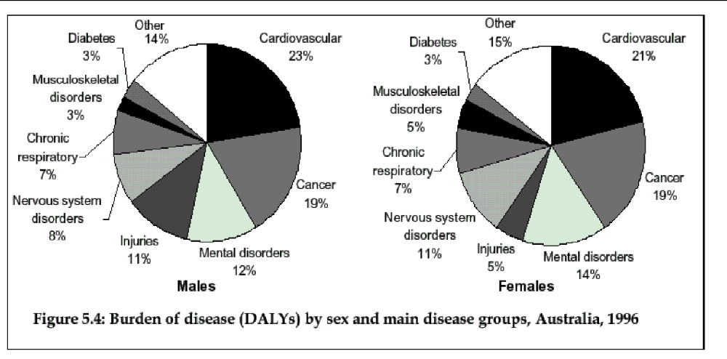
Source: Mathers et al. 1999. Burden of Disease and Injury in Australia. Australian Institute of Health and Welfare p.68

a. Describe what is meant by the burden of disease.

______________________________________________________________________________
______________________________________________________________________________
______________________________________________________________________________
______________________________________________________________________________
(2 marks)

b. Compare (look at similarities and differences in) the burden of disease for Australian males and females.
______________________________________________________________________________
______________________________________________________________________________
______________________________________________________________________________
______________________________________________________________________________
______________________________________________________________________________
______________________________________________________________________________
______________________________________________________________________________
______________________________________________________________________________
______________________________________________________________________________
______________________________________________________________________________
(2 + 2 = 4 marks)

NOTE: Images taken from: Beaumont, Key Concepts in VCE Health and Human Development Units 3 & 4, Jacaranda, 2011.

10. Read the media article ‘Ten Steps to a long life’ and answer the questions that follow.

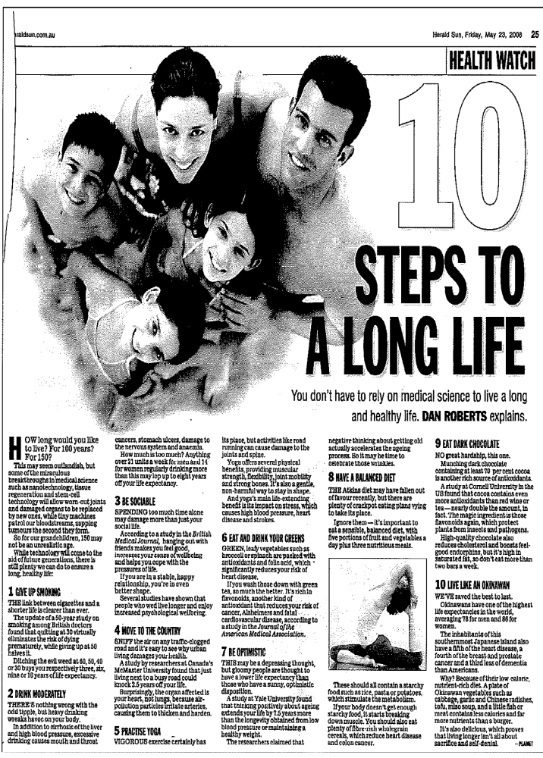
Give up smoking
1. If you give up smoking at
a. 60 how much extra life expectancy will this give you? __________________________
b. 50 how much extra life expectancy will this give you? _________________________
c. 40 how much extra life expectancy will this give you? __________________________
d. 30 how much extra life expectancy will this give you? _________________________
Drink moderately
2. List the diseases/conditions that are associated with an excessive consumption of alcohol. _______________________________________________________________________________
3. How many units of drink are considered to be too much for:
Males ____________________________
Females __________________________
4. If you drink excessively by how many years can your life expectancy be reduced? __________________________
Be sociable
5. How can ‘hanging out’ with friends increase your life expectancy?
____________________________________________________________________________________________________________________________________________________________

6. Are you more likely to live longer if you are married or single? Outline a possible reason for this.
____________________________________________________________________________________________________________________________________________________________
Live on a quiet road
7. If you live next to a busy road, your life expectancy could decrease by how many years? Why do you think that this is the case?
____________________________________________________________________________________________________________________________________________________________
8. Outline how pollution can affect your health. Explain which organ in particular is affected.
____________________________________________________________________________________________________________________________________________________________
Practise yoga
9. List the physical benefits of yoga.
____________________________________________________________________________________________________________________________________________________________
Eat (and drink) your greens
10. Name three green leafy vegetables.
______________________________________________________________________________
11. List the benefits of eating green leafy vegetables.
____________________________________________________________________________________________________________________________________________________________

Be optimistic
12. According to the Yale University study ‘thinking positively about ageing extends your life’:
a. By how many years? ________________
b. Explain why you think this might be the case. ______________________________________________________________________________
Have a balanced diet
13. List the foods which are important in a balanced diet.
____________________________________________________________________________________________________________________________________________________________
14. Evaluate your own diet. Is it balanced? Outline the reasons for your answer.
____________________________________________________________________________________________________________________________________________________________
______________________________________________________________________________
Eat dark chocolate
15. Dark chocolate is high in saturated fats; why then are small amounts beneficial in a balanced diet?
______________________________________________________________________________
Live like an Okinawan
16. The Okinawans have one of the highest life expectancies in the world. Explain how their diet contributes to their longevity:
____________________________________________________________________________________________________________________________________________________________
______________________________________________________________________________
______________________________________________________________________________
17. Advancements in technology have also played a part in the rise in life expectancy. List five technological advances that may have contributed to this increase.
____________________________________________________________________________________________________________________________________________________________
______________________________________________________________________________

News Item Scrapbook – Health Status of Australians

Collect two newspaper clippings on any aspect of health status of Australians. Paste them in the space provided on the next two pages and complete a brief evaluation. Below is a sample.

Newspaper: The Age
Date: November 19, 2010

Weight list grows for gastric banding
WEIGHT-LOSS surgery has more than tripled in Australia over the past 10 years, figures show.
A report released today by the Australian Institute of Health and Welfare shows the number of patients having weight-loss surgery - mostly gastric banding - grew from 500 in 1998 to 17,000 in 2007-08. The proportion of obese adults increased from 19 to 25 per cent over the same period, but experts say growth in surgery is also due to its better safety and effectiveness at achieving weight loss.
Weight-loss surgery grew at an average rate of 54 per cent a year over the past decade, compared to a 4 per cent increase in the total number of hospital admissions.
More than 90 per cent of the surgery, which cost an estimated $108 million in 2007-08, was performed in private hospitals.
Researcher Jenny Hargreaves said almost four in five admissions were women, who tended to be younger than men who had the surgery.
''This is somewhat disproportionate because, according to the 2007-08 national health survey, 68 per cent of men are overweight or obese while for women the figure is 55 per cent,'' she said.

1. Which health issue is the major focus of this article? Identify any interesting/alarming information.
____________________________________________________________________________________________________________________________________________________________
______________________________________________________________________________
______________________________________________________________________________

2. Outline the possible impact this health issue could have on the three dimensions of health.

____________________________________________________________________________________________________________________________________________________________
______________________________________________________________________________

3. Does this health issue impact more on YLLs or YLDs? Explain your answer.
____________________________________________________________________________________________________________________________________________________________
______________________________________________________________________________
______________________________________________________________________________

1. Health Status of Australians - News Item Analysis

Newspaper:
Date:

Paste article here

1. Which health issue is the major focus of this article? Identify any interesting/alarming information.
____________________________________________________________________________________________________________________________________________________________
______________________________________________________________________________
______________________________________________________________________________

2. Outline the possible impact this health issue could have on the three dimensions of health.

____________________________________________________________________________________________________________________________________________________________
______________________________________________________________________________

3. Does this health issue impact more on YLLs or YLDs? Explain your answer.
____________________________________________________________________________________________________________________________________________________________
______________________________________________________________________________
______________________________________________________________________________
______________________________________________________________________________

2. Health Status of Australians - News Item Analysis

Newspaper:
Date:

Paste article here

1. Which health issue is the major focus of this article? Identify any interesting/alarming information.
____________________________________________________________________________________________________________________________________________________________
______________________________________________________________________________
______________________________________________________________________________

2. Outline the possible impact this health issue could have on the three dimensions of health.

____________________________________________________________________________________________________________________________________________________________
______________________________________________________________________________

3. Does this health issue impact more on YLLs or YLDs? Explain your answer.
____________________________________________________________________________________________________________________________________________________________
______________________________________________________________________________
______________________________________________________________________________

