Worksheet for 24/6/13
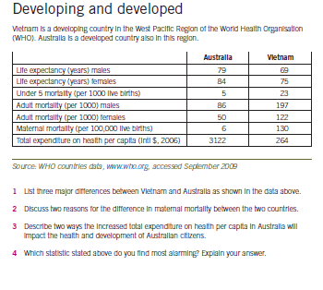
Define and learn the following key terms
Key terminology | Definition
Developing countries
Human development ( refer to VCAA)
Sustainability
WHO regions
Morbidity
Mortality
Life expectancy
Burden of disease
Infant mortality rate
U5MR
Gross domestic product
Human development index
Communicable disease
Maternal mortality
Fertility rate
DALY
Non-communicable disease

